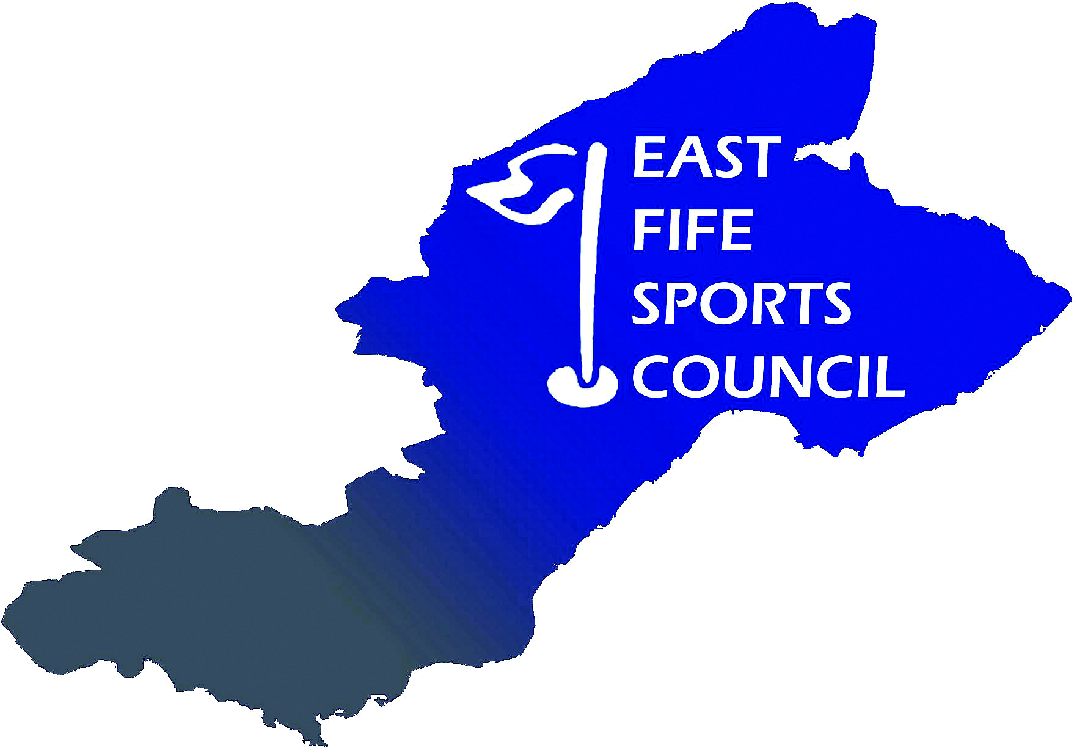
East Fife Sports Council
Complaints Policy

East Fife Sports Council (EFSC) is committed to the provision of high-quality services.

Occasionally, within any organisation, things can go wrong. When this happens, we will investigate all complaints received and communicate outcomes to you. Your views are important to us and will be used to help us plan and improve our services for the future.

Our promise to you:

- To provide a sympathetic, fair and consistent approach to resolving complaints
- To investigate fairly all aspects of your complaint
- To keep you informed of progress.

Should you have a complaint to make, the steps below lay out how to do so.

How do I make a complaint?

Many complaints can be resolved informally. In the first instance, you may wish to take the matter up either through the Secretary or Chairman, by contacting secretary@eastfifesportscouncil.org.uk

If this does not resolve your issue, or if you want to make a formal complaint, you should complete a Complaints Form (below) and email it to secretary@eastfifesportscouncil.org.uk.
Data Protection Act 2018 – the information you supply will be maintained in accordance with the Act. It will not be passed to any other person outside EFSC, without your prior consent, unless this is a legal requirement.

What will happen when I make a complaint?

EFSC will try to resolve complaints informally where possible. If your complaint cannot be resolved informally then, we will:
- Send a written acknowledgement of your complaint within 7 (seven) working days
- Carry out a thorough investigation of your complaint
- Write to update you every 21 (twenty-one) working days until complete.

Exceptions

Correspondence that is abusive or contains allegations that lack substantive evidence will not be progressed. Complainants will be:
- Told that their language is considered offensive, unnecessary and unhelpful
- Asked to stop using such language
- Informed they may cease to receive a response if they persist in this.
They may be informed that future contact will be required to be made through a third party.

Where a complainant repeatedly contacts EFSC, sends irrelevant documents or raises the same issues, the following actions will be taken:
- The complainant will be required to make contact in writing only
- Documents will be returned to the complainant in extreme cases the complainant will be advised further irrelevant documents will be destroyed
- Other action, the complainant will be informed of what other action is being taken
and why.

What if I am still not happy?

- You have a right to appeal to the Chairperson, or a representative of EFSC Executive Committee, who was not involved in the original decision, for a further investigation. The appeal must be made within 14 (fourteen) working days of receiving the response to your original complaint.
- The appeal will be received by the Chairperson, or a representative of EFSC Executive Committee, who was not involved in the original decision, and will be acknowledged in writing within 7 (seven) working days.
- The Chairperson, or a representative of EFSC Executive Committee, who was not involved in the original decision, will carry out an appeal investigation seeking to negotiate an acceptable resolution.
- An update will be provided every 21 (twenty-one) working days until complete.

Taking complaints out with EFSC

The Chairman’s decision marks the end of our complaints procedure. However, if you are still not satisfied, you have the right to take your complaint to independent arbitration.

East Fife Sports Council
Complaints Form

Name:
Address:
Telephone:
Email:
Nature of Complaint
Please include any documented evidence to support your complaint

Please return this form to: secretary@eastfifesportscouncil.org.uk

