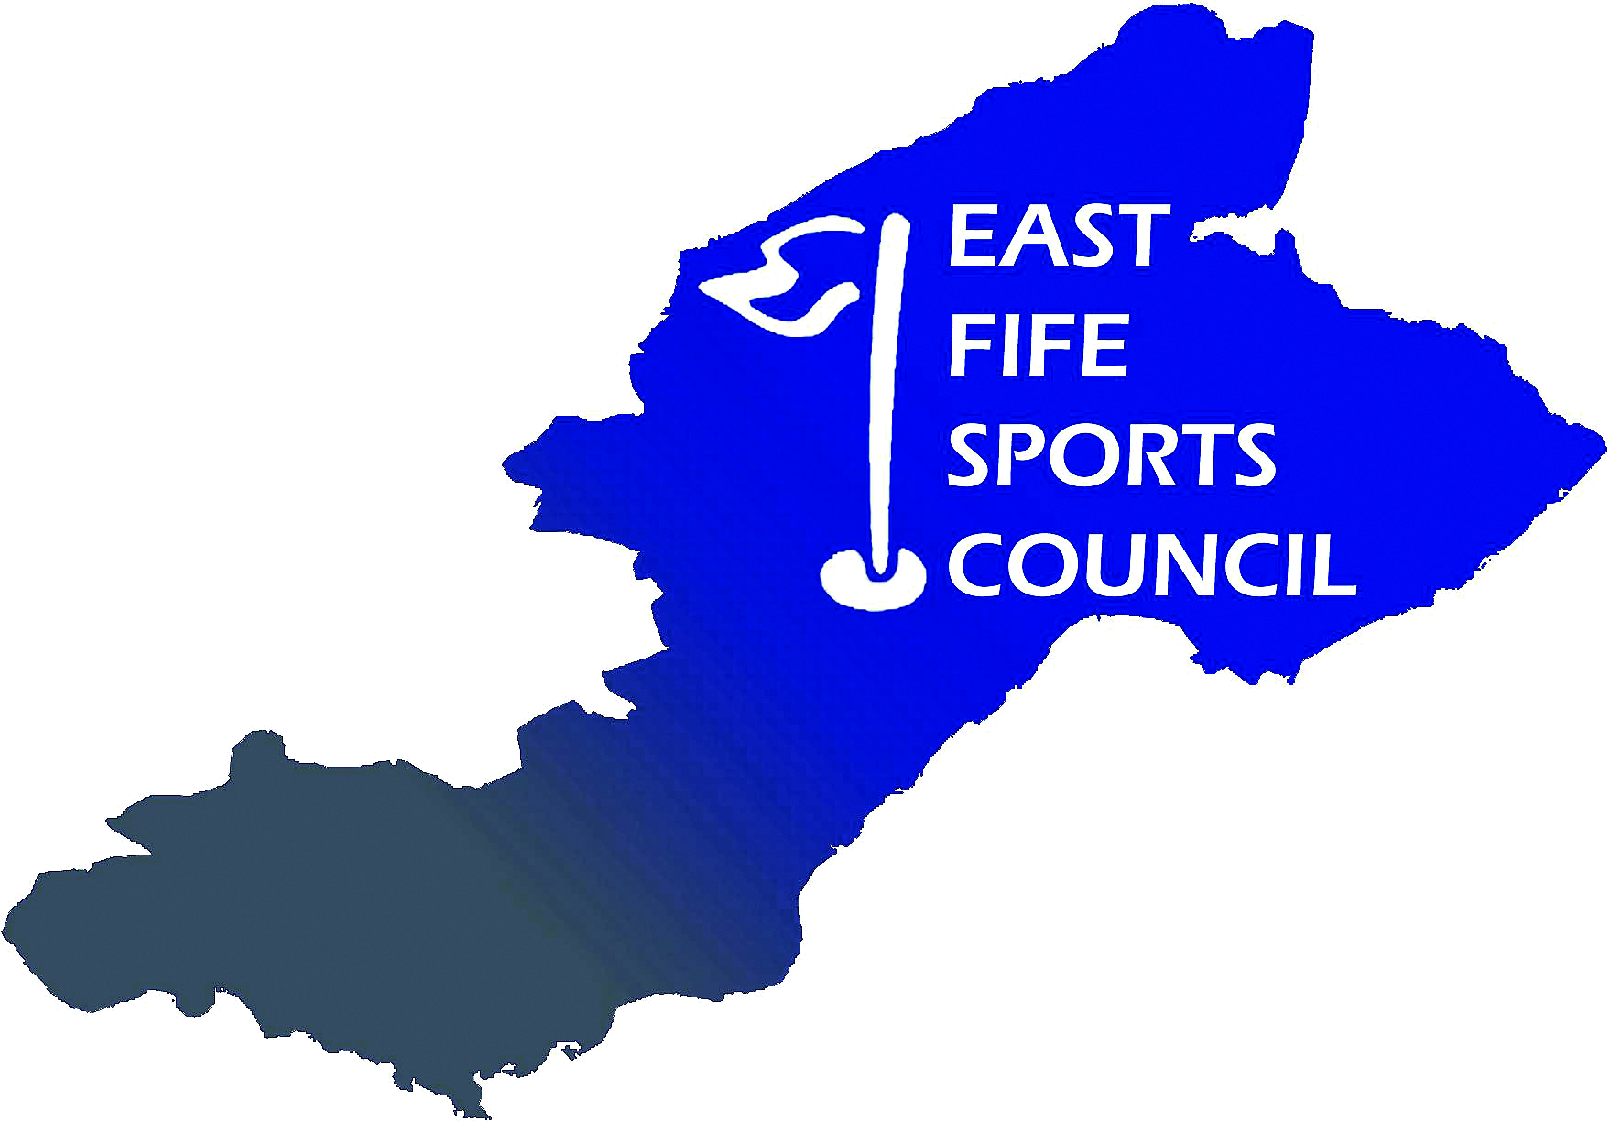

East Fife Sports Council
Protection of Vulnerable Adults / Adults at Risk Policy

This policy applies to anyone aged 18 (eighteen) or above who may need community care services for reasons like mental health issues, disability, age, or illness. They are considered more ‘vulnerable’ because they may not be able to protect themselves from harm or exploitation.

It is the policy of the East Fife Sports Council (EFSC) to safeguard vulnerable adults taking part
in sport from physical, sexual or emotional harm. EFSC will take all reasonable steps to ensure
that, through appropriate procedures and training, vulnerable adults participating in EFSC’s activities
do so in a safe environment.

EFSC actively seeks to:

- Create a safe and welcoming environment where participants can have fun and develop their skills and confidence
- Support and encourage affiliated clubs and associations to implement similar policies
- Recognise that safeguarding vulnerable adults is the responsibility of everyone, not just those who work directly with them
- Ensure that EFSC organised training and events are run to the highest possible safety standards
- Be prepared to review its ways of working to incorporate best practice.

EFSC will:

- Treat all participants with respect and celebrate their achievements
- Carefully recruit and select all employees, contractors and volunteers
- Respond swiftly and appropriately to all complaints and concerns about poor practice or suspected or actual abuse.

This policy relates to all employees, contractors and volunteers who work with vulnerable adults in the course of their EFSC duties. It will be kept under periodic review. All relevant concerns, allegations, complaints and their outcome should be notified to the Secretary or Chairperson of EFSC.

