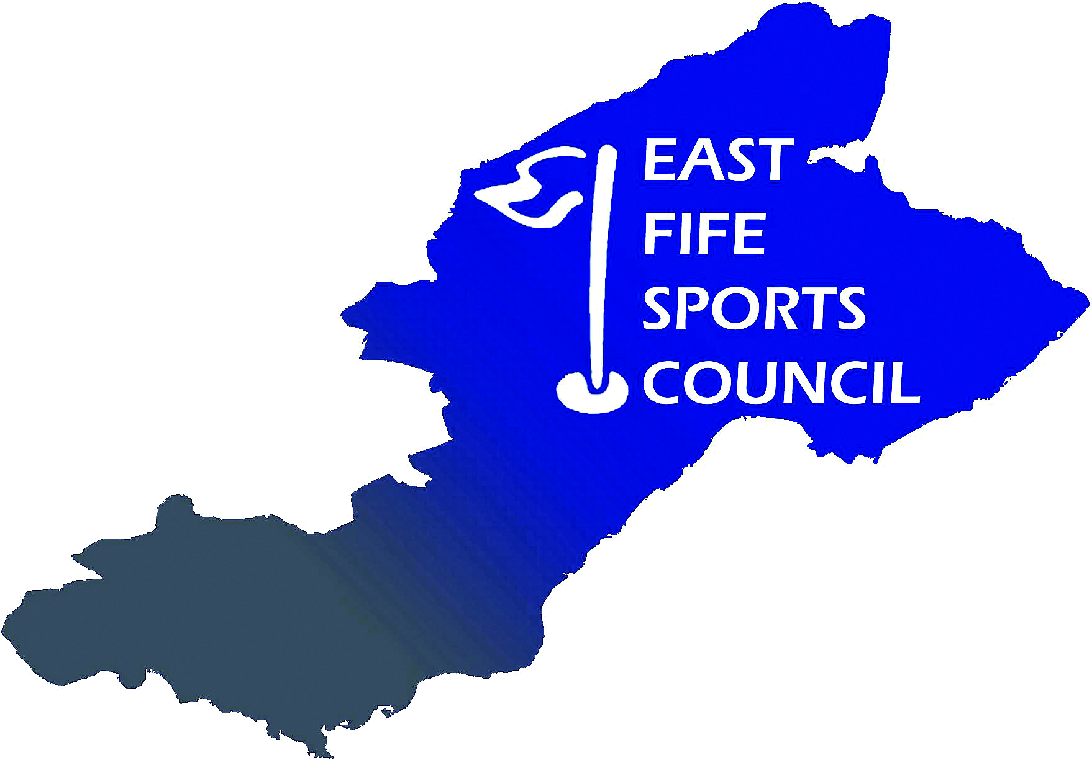

East Fife Sports Council
Unacceptable Actions Policy

East Fife Sports Council (EFSC) is committed to dealing fairly, honestly, consistently and appropriately with all complainants, including those whose actions are considered unacceptable. However, we must also ensure that an excessive amount of time is not taken up in dealing with complainants, whose behaviour is unacceptable, to the disadvantage of other complainants or functions. This policy is designed to ensure consistency in dealing with unacceptable actions.

Definition of unacceptable actions

People may act out of character in times of trouble or distress. There may have been upsetting or distressing circumstances leading up to a complaint being made. EFSC do not view behaviour as unacceptable simply because an individual is forceful or determined.

We have grouped unreasonable or unacceptable behaviour under 2 (two) broad headings:
- Aggressive or abusive behaviour – violence and aggression are not restricted to acts that cause physical harm. They also include behaviour or language – whether oral or written – that may cause another person or party to feel afraid, threatened, harassed or abused.
Examples include threats, physical violence, personal verbal abuse, derogatory remarks and rudeness. Inflammatory statements and unsubstantiated allegations can also be considered as abusive behaviour.
- Unreasonable demands – a demand becomes unacceptable when it starts to (or when complying with the demand would) impact another person or party substantially.
Examples include demanding responses with an unreasonable timescale, insisting on seeing or speaking to a particular individual, continual phone calls or letters, repeatedly changing the substance of the complaint or raising unrelated concerns.

Scope

The approach applies to individuals, organisations and individuals on behalf of organisations who have contact with EFSC. For ease of reference, individuals are referred to below, but the approach applies equally in our dealing with others.

Key principles

EFSC will aim to:
- Make it clear to individuals within 7 (seven) working days of written contact with EFSC what we can or cannot do in relation to the complaint, enquiry, or issue
- Deal fairly, honestly, consistently and appropriately with all individuals, even those whose behaviour or actions is considered unacceptable
- Believe that all individuals have the right to be heard, understood and respected
- Provide a service that is accessible to all.

EFSC does not deal with correspondence or telephone calls that are abusive or contain allegations that lack substantive evidence. In the case of abusive behaviour individuals will be informed in writing why a decision has been made to restrict future contact, the restricted contact arrangements and, if relevant, the length of time that these restrictions will be in place.

An individual can appeal a decision to restrict contact. A representative of EFSC Executive Committee, who was not involved in the original decision, considers the appeal. The individual will be advised in writing that either the restricted contact arrangements still apply or a different course of action has been agreed.

