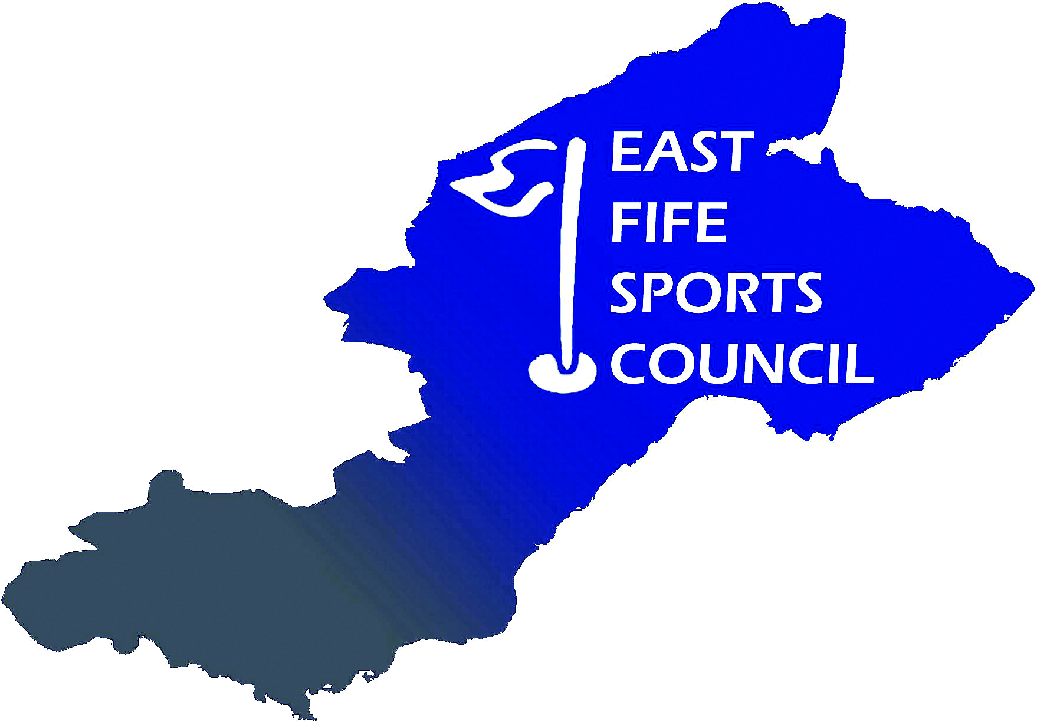

East Fife Sports Council
Privacy Notice

What we need

East Fife Sports Council (EFSC) is a 'not-for-profit' organisation.

EFSC will be a ‘controller’ of the personal information that you provide to us in affiliation forms, booking forms, entry forms, application forms and awards nomination forms, through our website and by post.

Members’ personal data

When you register as a member of EFSC or renew your membership we will ask you for the following personal information:

Contact Details – full name, address and postcode, email address, telephone or mobile number for the person who will act as the contact for EFSC. Contact email addresses for additional members who may wish to receive information from EFSC if requested.

Volunteers’ personal data

When you volunteer with EFSC, we will ask you for the following personal information:

Contact Details – full name, address and postcode, email address, telephone or mobile number.

- Purposes and your personal information may also be used in images captured from our events, which we use for promotional and development purposes
- Monitor and develop participation by monitoring members’ engagement and participation through attendance and inviting our members to participate in surveys for researching and development purposes
- Invite our membership as award winners to our annual awards, which includes asking our membership to nominate themselves of others for awards and shortlisting members to select winners who we will contact by post, email or telephone
- Develop our memberships qualifications, including sending email communications informing of training courses and workshops, including sending members communications regarding external agencies upcoming courses which may be of interest
- Respond to and communicate with members regarding your questions, comments, support needs in relation to your organisation or EFSC
- Any other legitimate interests and details of uses of personal data.

Where we process your personal information in pursuit of our legitimate interests, you have the right to object to us using your personal information for the above purposes. If you wish to object to any of the above, please contact us at sectretary@eastfifesportscouncil.org.uk. If we agree and comply with your objection, this may affect our ability to undertake the tasks above for the benefit of you as a member.

