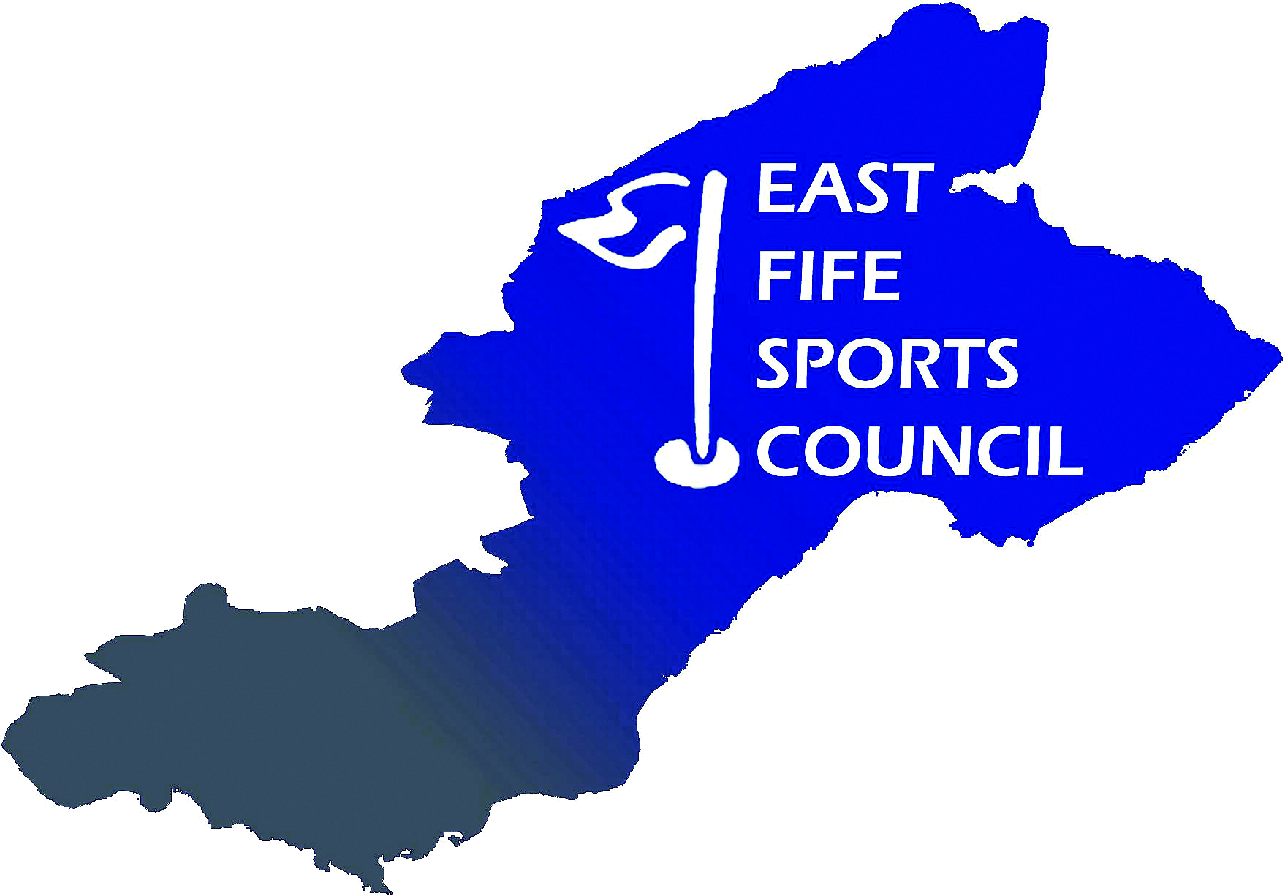

East Fife Sports Council
Equal Opportunities Policy

East Fife Sports Council (EFSC) is strongly committed to equal opportunities for all sectors of the community.

The objectives of this policy are to prevent, reduce and stop all forms of unlawful discrimination, harassment, victimisation and/or bullying, as may be required to comply with the Equality Act 2010 and to ensure that all EFSC members, participants, volunteers and employees receive equal treatment regardless of age, disability, gender reassignment, marriage and civil partnership, pregnancy and maternity, race, religion or belief, sex, sexual orientation.

EFSC will ensure all members, participants, volunteers and employees have equal opportunities by:

- Eliminating any barriers or ‘perceived’ barriers to participation within EFSC
- Ensuring that all members are aware of, understand and follow this policy
- Increasing awareness within EFSC of the needs of those who face discrimination
- Ensuring that EFSC considers equal opportunities in all its activities
- Ensuring that EFSC premises are accessible to all, including those with physical disabilities
- Responding swiftly and appropriately to all complaints and concerns
- Ensuring that the implementation of the policy is reviewed regularly and monitored for effectiveness.

Reporting a concern

EFSC urges all members, participants, volunteers and employees to come forward with any concerns at an early stage before the problem has a chance to become serious, and to refer to and follow EFSC:
- Complaints Policy
- Unacceptable Actions Policy
- Disciplinary Procedure.

