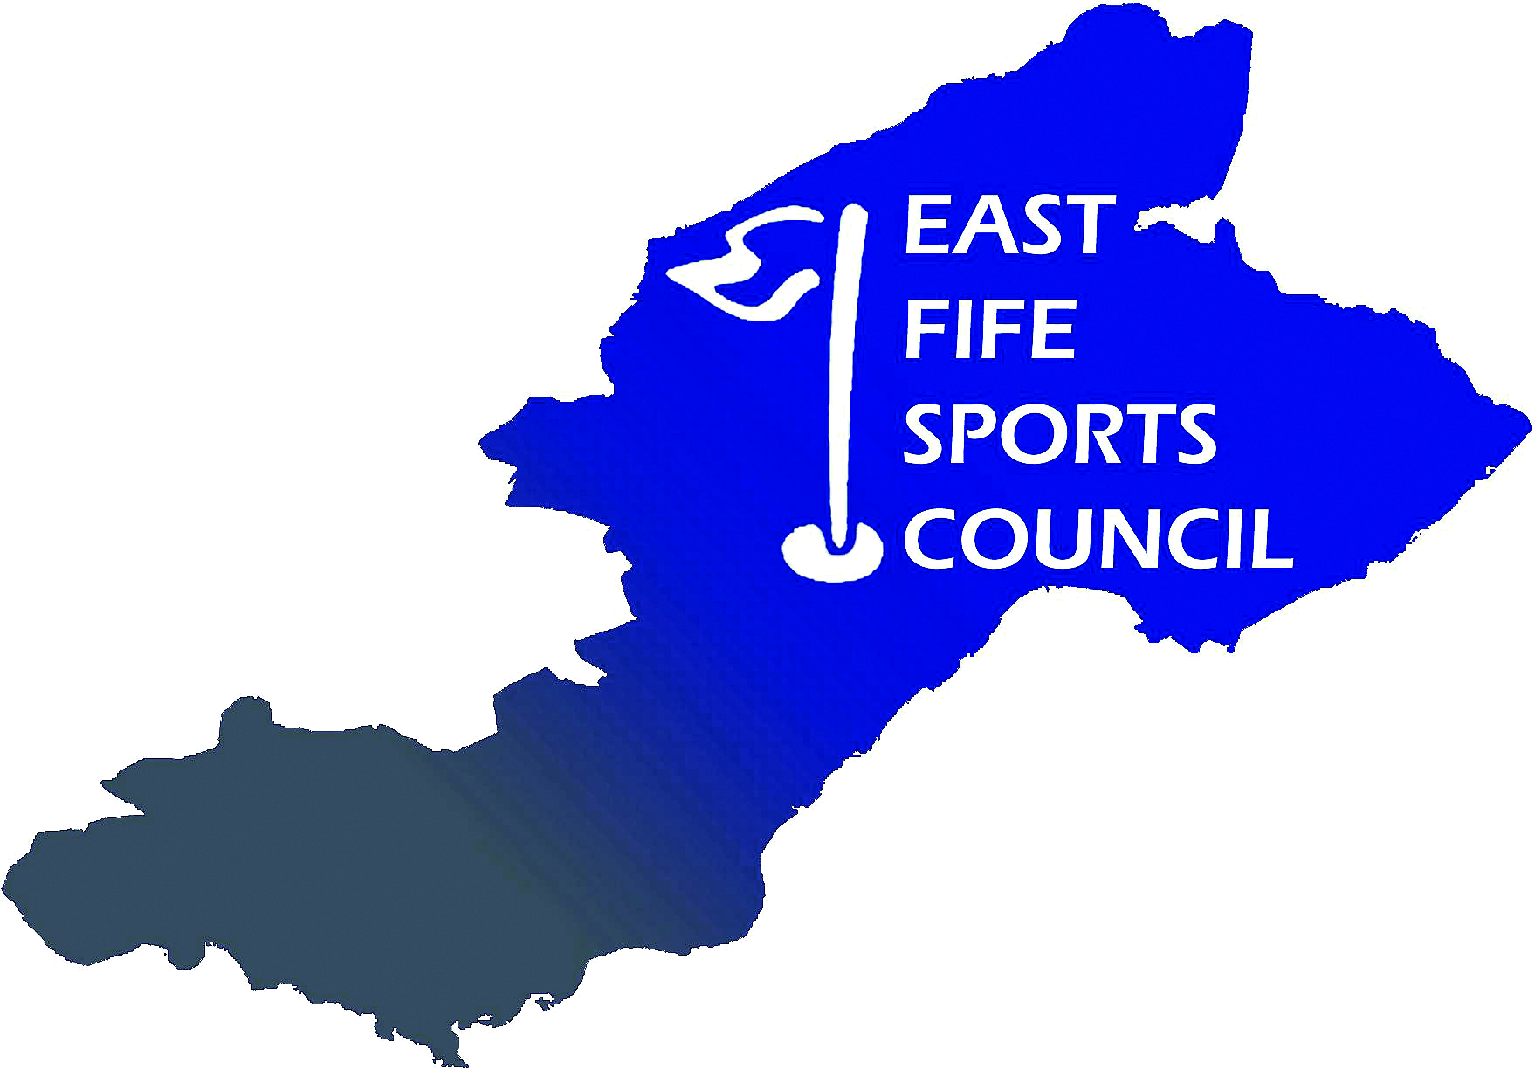

East Fife Sports Council
Child Protection Policy

East Fife Sports Council (EFSC) is fully committed to safeguarding, promoting and supporting the protection and wellbeing of all children and young people in its care. It recognises the responsibility to promote safe practice and to protect children and young people from harm, abuse and exploitation. For the purposes of this statement a child and young person is recognised as someone under the age of 18 (eighteen) years.

Employees and volunteers will work together to embrace difference and diversity and respect the rights of children and young people.

This document outlines EFSC’s commitment to protecting children.

These guidelines are based on the following principles:

- The welfare of children is the primary concern
- All children, whatever their age, disability, gender reassignment, race, religion or belief, sex, or sexual orientation, have the right to protection from all forms of harm and abuse
- Child protection is everyone's responsibility
- Children have the right to express views on all matters which affect them, should they wish to do so
- Organisations shall work in partnership together with children and parents/carers to promote the welfare, health and development of children.

EFSC will:

- Promote the health and welfare of children by providing opportunities for them to take part in sport safely
- Respect and promote the rights, wishes and feelings of children
- Promote and implement appropriate procedures to safeguard the wellbeing of children and protect them from abuse
- Recruit, train, support and supervise its staff, members and volunteers to adopt best practice to safeguard and protect children from abuse and to reduce risk to themselves
- Require staff, members and volunteers to adopt and abide by this policy and these procedures
- Respond to any allegations of misconduct or abuse of children in line with this policy and these procedures as well as implementing, where appropriate, EFSC’s Disciplinary Procedure
- Observe guidelines issued by local Child Protection Committees for the protection of children
- Regularly monitor and evaluate the implementation of this policy and these procedures.

This policy and these procedures will be regularly reviewed:

- In accordance with changes in legislation and guidance on the protection of children or following any changes within EFSC
- Following any issues or concerns raised about the protection of children within EFSC
- In all other circumstances, at least every 3 (three) years.

