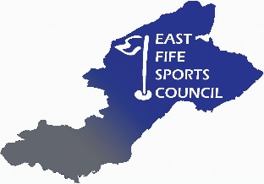

MINUTES OF THE EAST FIFE SPORTS COUNCIL
SPECIAL GENERAL MEETING
19th September 2019 at 6.45pm
Duffus Park Bowling Club, Carslogie Rd, Cupar

Attendance Present:
Rona McCraw – Chair
Robbie Nellies – Deputy Chair
Hilary Lumsden – Secretary/Treasurer
Jamie Moffat – Sports Development Officer
Caitlyn Mackie – Active Schools Coordinator
Mandy Strachan – Tayport Tennis Club
Margaret Kennedy – Councillor
Elspeth Wallace – Fife AC
Mark Smith - Fife AC
Gillian Paton – Ladybank Golf Club

- Proposed changes to the EFSC Constitution
Changes to the EFSC Constitution were unanimously agreed. Proposed by Rona McCraw and seconded
by Margaret Kennedy.

